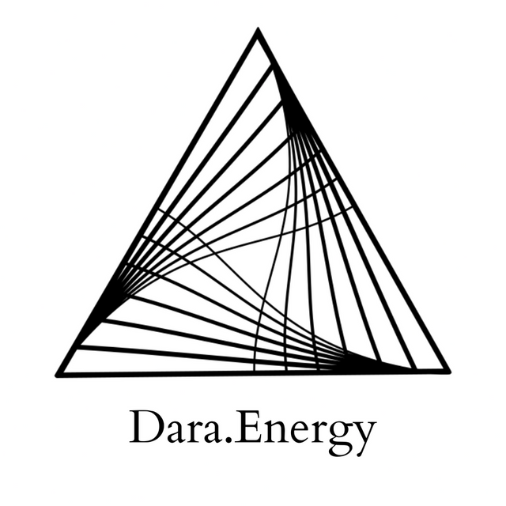

Healing the Earth (Dis)Connection

Hello, I'm Darananda. And this is a session focused on healing our relationship to the Earth.

So I will just spend a few moments speaking about the topic as a way to have us become aligned and connected to what wants to come through.

And currently, I am in New Mexico, in the United States of America, and I'm in Santa Fe, on top of a mountain. So I'm somewhere near 8,000 feet above sea level. And I just went on a short hike nearby, and sat with the rocks, and boulders, and land here. So just coming to this session with some of that energy. Already feeling that groundedness. It's also in my awareness from my walk, and also my time here, that it's quite literally burning. There are fires and even though the fires aren't very close to where I am, there are lots of charred pieces of wood around, and you can kind of feel the impact of this intense energy moving through the place. So while fire is natural, elemental, and part of healthy ecosystems, it feels like a particular metaphor.

And just as I say that, I can feel this connection of the heart and the solar plexus. It's almost like being stabbed through the body with metal in these two places. And the emotional quality here is complex. There's something very, very deep and old. We could say indigenous, like the original peoples of the land here, and wherever you are receiving this. But it's almost even before the concept of an “us” and “them”-- a particular way of separating the human from the Earth. It's more like the Earth, herself.

And I'm just understanding how, there is this relationship where the Earth is able to speak through many forms.
So, at once there is that wholeness of the planet, the Earth herself, the being that is Mother Earth. Her place in the cosmos, the intergalactic. and universal connection. And then the ultimate wholeness that is Source. So, all of these levels, that create this wholeness at the smaller, fractal pieces that Mother Earth is speaking to us through. So there is both the oneness and the many.

And the voice is saying “Don't you see? My dear child, don't you see? It is not me that you are destroying, it is yourself. It is your being. It is all of us.”

And just as I'm speaking this, I can feel the sunrays pouring in. And the sun is like the ultimate compassionate being–always shining, always offering the warmth. And it is like he is affirming, directing our attention: “Listen deeply to this message. It is not the earth that is that is being destroyed, it is yourself. There is no separation.”

And I feel that in the heart. And so, it is that we, as humans, have a particular opportunity with this nervous system we are blessed with. It is to overcome the wound and the belief of separation. And the Earth is cheering us on. And so is the Sun. They're saying: “Don't you see? We actually are not separate. Simply the many expressions of wholeness, of oneness.”
And I can feel this deepening in the body, moving from the solar plexus down into the gut. Again “Don't you see?” And it descends further into the root, this energy, this opening, this connection. We have the opportunity to be the full conduit, the channel, of these energies, of the Earth, the Sun, the wholeness.

And I feel the feet opening. And the Earth Star, this chakra below the feet, it is pulsing. Becoming more energized, rejoicing. She says “Don't you see? We are one.”

And the heart opening further as the energies meet and their recognition deepens “Don't you see? We are one.”

And I have this sense of friendly birds circling above. Welcoming us deeper into our true nature, into our Earth nature, into our animal, our wild our heart.

May we all find the connection that deepens our trust and knowing that we are held. That we are one. And that we are fully alive in this life.

And She thanks us, She is satisfied and pleased. And She asks: “Don't forget me.” We can speak to her. We can remember our connection. We can learn to dialogue and dance with the elements. And we can once again become One with being.

Thank you for receiving this transmission.

© 2022 Soma Developmental LLC

All rights reserved. No part of this publication may be reproduced, distributed, or transmitted in any
form or by any means, including photocopying, recording, or other electronic or mechanical
methods, without the prior written permission of the publisher.

