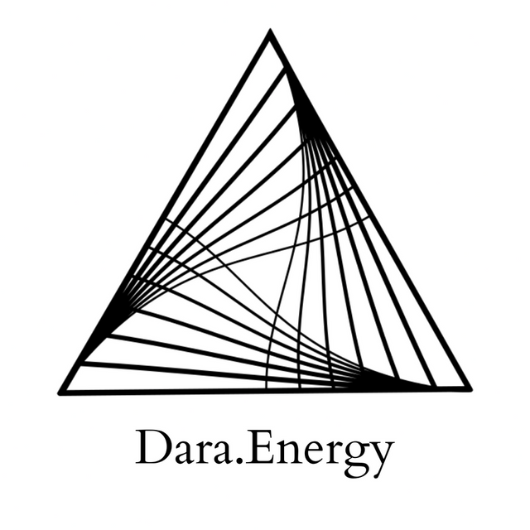

Healing for Codependency and Attachment Wounding
Hello, I'm Darananda, and this is a healing for codependency and attachment wounding.

Just going to begin by offering a little bit of context on this particular healing, and then I'll just go right into the healing aspect.

So this time that we're in right now, as a global humanity, as a species, is one where I believe that codependency as a way of relating, as a way of making relationship–which precludes the possibility of actually healing the attachment wounds–is dying. So this as an energetic structure that has permeated human culture for a long time now, the codependent relationship, which shows up like, everywhere, not just like in romantic relationship, but shows up all over the place. And the kind of basic contract or agreement of, of these relationships, of these relational dynamics, goes something like: “I won't upset your ego, if you won't upset mine.” So that's the agreement. So it's not a relationship that's founded on truth, or honesty. It's a relationship that's founded on not creating too much disturbance in the field. So that the relationship can continue. So as a human species, with these very sophisticated, very, very special nervous systems, consciousness is arising and we're being called, are being in some cases pushed forward, into a place where we can begin to do something like what I call real relating.

And part of real relating is a commitment to self responsibility, sovereignty, being able to be responsible for what's showing up in your life at some level. So as more and more people are waking up to how limiting and confined these codependent relationships make them feel because that's their condition: their condition is to be limiting. We're starting to see more and more ruptures across the human field of relating and they can show up in small ways, and they can also show up in much larger ways. Anyway, healing our attachment wounding, moving beyond codependency, being able to be sovereign and self responsible– these are the capacities that are needed for us to evolve. Certainly. And in some ways just really survive the next couple of decades. It's time to get real.

And just beginning by dropping into the direct experience. And just seeing if we can find this seed, we can go right down into the core of this issue. And I'm just being drawn right into the center of the chest. I'm just exploring that area a little bit with my, with my, fingers. It's like right where the the ribs open, right at the top there. And it's like in an upper little there's like a very acute tenderness. There's a little voice that's like “Help.”

So I'm feeling the desire for basically the heart to break open, to break out beyond all of the walls, and shields, and cages, that we as a species have kept the heart inside of for a very long time. And often these particular structures around the heart are are passed on ancestrally. So for example, I can give you an example from my life that when I was working through an ancestral lineage healing process that I did on my four blood lineages. And I did this with Dr. Daniel Foor, who I recommend. When I was working on my father's father's line, I discovered like a metal plate, what felt like a metal plate like in casing my heart so I was like okay, now there's a metal plate here like how do I, how do I work to remove that?

So it's like we don't even know we're not even really aware of these, these bought these binds that we have in our own system until we really start looking for them and trying to release ourselves. So this sense of “I don't necessarily know what's keeping me feeling so stuck, and so limited, but I know that there's more.” And that's like, that is this, tender desire of the heart that is showing up here right at the beginning.

And then, of course there's fear. I'm hearing: “I am nothing without you.” Which I take as a real existential experience that lives deep inside of this system. When we're talking about attachment wounding, we're talking about the first 18 months of life. So literally: survival. The human baby cannot survive without an attachment figure, without a parent, without a guardian, without deep and sustained care.

And just that fear is softening. It's like “I am nothing without you. I can't survive without you. And because my survival is dependent on you, I will do and be however, is best for you.” And I think it's worth saying here that when we are this little, when we are this young– infant experience–we are incredibly aware and sentient. Like it's not like the baby is dumb and unaware, because it's not yet rational. It's like the baby is oneness. It is this incredible infant consciousness that so many of us have to trade for survival.

So many generations now of unprocessed trauma that we're at a breaking point here. And we live in a relatively abundant situation. That in one way it's safe enough, it's worth it to heal this. So I'm just inquiring directly into being: how can we stop replicating these relationships?

And one of the answers in response that I hear is: fierce compassion. Fierce compassion. And that carries with it an energy signature that feels incredibly powerful, stabilizing, and just grounding. Like really connecting with the earth like it has a downward pull. Fierce compassion for self, and other.

And I'm just inquiring: what else is needed? And, yeah, it feels like, what we can do here is we can just unpack this a little bit more.

So fierce compassion, which is this stabilizing energy, that's also open. And it feels like it's wise in terms of boundaries. And I want to say a little bit here about the stabilizing aspect. So this stabilizing aspect is about growing the capacity to hold yourself, your nervous system, your inner children, in your own experience. As adults, in codependent relationships, we're always making the other person responsible for our experience. So the more that we can ground and stabilize our own nervous system, so that we can hold ourselves in our experience.

So there's just a download that's coming in, of divine energy. In this, downloads, they just come right in through the crown. And this energy is to fortify your nervous system to be able to continue to learn how to hold yourself in your own experience and not make it anyone else's problem.

That doesn't mean that you can't share your experience with someone, or negotiate boundaries, or discuss maybe what happened in a dynamic or an interaction. But it's to say, “I'm having this experience. Can we talk about it?” Not you made me feel you did this, you did that? It's “I'm feeling hurt. I'm feeling confused. Can we look at that together?”

And so the attachment piece is coming in here because a lot of what is happening in attachment wounding is that there's projection. Which is what I'm talking about, right? So how can we reclaim the aspects of ourselves, of our own being, of our own wholeness, that we are projecting out onto the other? We're projecting out onto the other and we're making the other responsible for, and to, these aspects of ourselves that we are actually responsible for. They're actually our responsibility. So just inquiring how to work with this projection aspect. And it's interesting, it shows up higher in the chest, also in the heart, but it's higher. Not as high as like, the higher heart chakra, the thymus, but just up in the chest, center of the chest. Like a couple inches, two or three inches, below the clavicle.

And it's just grief. “I didn't get what I needed. I didn't get what I wanted. I wasn't seen. I wasn't heard. I wasn't attuned to. There was no one there to help me understand my experience. There was no one there to help me understand my experience.”

And this feels like really new information, for me, in a way ,it's like a new framing. What I'm understanding is that as we play out our attachment wounding, it's like a call. It's a desire, that we're trying to get met. A need that we're trying to get met. That is saying, “Help me understand my experience. attune to me. Help me understand what's happening.”

Unfortunately, it gets expressed in this very young way: “You did this, you did that, you're making me feel XYZ. It's all your fault.” When really I think what is being expressed is: “help me understand what this experience is, and why it's here.”

There's just a clearing moving through the heart now. It's clearing up the chakras.

And I'm just hearing a little bit of a different twist on that.

It sounds like “Divine Being, help me understand my experience.”

There's like a deep unwinding, or unbinding happening in the heart, the center of the heart right now.

“Divine Being, help me understand my experience.”

“Divine Being, help me understand that I matter. No matter what. I matter.”

There's just expansion moving throughout the whole heart chakra.

Just a lot of clearing.

It is only through sovereignty that Divine Union can happen.

If we are not sovereign, then we end up in codependence and entanglements.

So may this be supportive to you on your journey, and thank you for receiving this transmission.

© 2022 Soma Developmental LLC

All rights reserved. No part of this publication may be reproduced, distributed, or transmitted in any
form or by any means, including photocopying, recording, or other electronic or mechanical
methods, without the prior written permission of the publisher.

