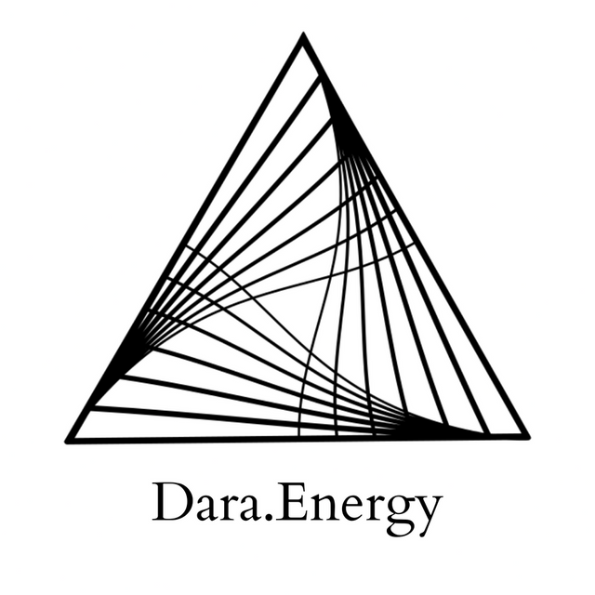

Healing for Scarcity at Multiple Scales

Hello, I'm Darananda, and this is a healing for scarcity and financial trauma. And just the general feeling that there isn't enough. And sometimes this can also show up as “I'm not enough.” So I'll just say a few words about this topic and then that'll take us into the healing.

Just starting with there, with that sense, of “I am not enough.” And sometimes the “I am not enough” also shows up with the “I'm too much.” So, for example, if someone has this experience of not ever making enough money, they may also feel like they can't ask for more. That would be too much. So there's a way that the lack, the scarcity, also almost precludes the ability to ask for more. Or to feel like more is what's right. That one deserves more.

And also, I just want to mention here in terms of scarcity, and this teaching that's called the three poisons from Buddhism. And the three poisons, the translation I like to use the most is: grasping, aversion, and ignorance. And just generally, the three poisons are, these are ways of being part of our conditioning, that takes us out of the present moment. And that creates suffering. So what is most of note here, is grasping.

Another way that we can talk about grasping is greed. It's like an insatiable desire for more. And it can show up in all sorts of ways, but I just want to introduce it here at the top. because it definitely feels related.

And just beginning here by dropping right into the lower chakras: solar plexus, sacral, and root. And most notably, just dropping all the way down into the root. And what I'm present to is the way that the root, it’s like I feel it go, I don't know, maybe four or five inches down into the Earth and then it stops. Like there isn't a full, rooted Earth connection here. And then the other thing that's just very present is a very complex, and dense set of emotions, and energetics in the belly.

So we're just starting there: with clearing the belly. Addressing these energetics and I'm just changing my position so that my lower body is more open. It's interesting, as I, as I shifted my physical body position, I can feel how there is a particular stability offered by the upper part of the spine. But again, it's like there's a disconnect from the lower chakras. So, let's come back to that. So yeah, there's just this very dense, and complex–like tangled– like very tangled, knotted set of emotions and energetics in the belly.
And I can hear the suffering. As they're clearing, and they're clearing up the central channel, I can hear the suffering that's like compacted in these energetics.

And I'm just getting a sense of how the core belief of “there's not enough, I'm not enough”, whatever the scarcity sounds like in your system. It's like what I'm hearing in terms of the suffering is what undergirds or underpins that core belief. And it's so clear to me that yes, while there is a personal aspect that you might experience, this is largely intergenerational. But even more than that it's ancestral: it's many, many, many, many generations.

And I'm just gonna stay with this clearing all the way. Yeah, and I'm just feeling how this, this suffering that's related to scarcity, related to they're actually not being enough in the past– 8, 16, 24 generations back depending on your lineages– but how that actual scarce situation has conditioned the nervous system, and has conditioned, it’s epigenetic. So it's conditioned the energetic structure from which the nervous system grows and becomes physical. So. So I'm feeling how this suffering has literally conditioned the expression of the solar plexus, the personal experience of power, empowerment, the right to come into one's power. It's like, there's a certain level of shutdown. Like, it's like that's been turned off a little bit. In the solar plexus. And then it's even more so in the sacral, which is creative lifeforce, sexuality, and this place where we learn to honor one another. So it's this relational aspect of power. And how this, in some cases, was impossible to be learned or enacted because there wasn't balance, there like was in an even playing field in a way, because there was this scarcity.

So ancestrally, there is in the root an insecurity. And that's what we were sensing into right at the beginning where it was very clear that the root connection was not full and alive into the core of the Earth. And I'm just feeling a particular energetic connection coming into the crown right now. And it's feels very golden, and there's an energy here of forgiveness. And there's, it's just, it's just kind of streaming down the whole system. So this energetic of forgiveness. It's just streaming down the whole system. And being offered right into the root, and being offered to all of those generations of ancestors who basically have created the conditions for you to experience scarcity in your DNA. So we're just starting with forgiving them for creating these conditions. And I'm just seeing how this forgiveness is enabling the reopening of the root into the Earth energies.

So yeah, this is important. So it's like the cutting off of the abundance of the Earth, which was experienced in the scarcity, which creates the condition of insecurity in the root. So we're just opening that reviving, revitalizing the channels. It's like a root system is growing down and being filled with the golden energy medicine. And this golden energy is just opening the pathways so that the energy of the Earth can come back in. And also, I just want to note that like the energetic of this whole experience in the crown is like cooling. Like the energy literally feels cold in my crown. And you know, sometimes cold is soothing. Especially, in this case, like there's definitely a warmth to the gold, but also it's carrying with it this coldness for whatever reason.

And so what I'm encountering now is how there's this shadow, this ancestral shadow of the desperation, and the shame, and the disconnection from wholeness, that led some ancestors to commit some very dark acts out of scarcity. So it's like some very dark experiences had to be had, in order to try to combat or negotiate this real experience of scarceness. That was there, it was real. Less like we experience in the West today, where we are actually living in a quite abundant situation. It may not feel that way for everyone, because so many people–including those who are in power and control of so many resources– still live with scarcity. So that is to say: if everyone healed their scarcity, there would be more than enough to go around.

And I just want to really make clear that this is a collective healing. It's not personal. I'm not saying like, certain people, or even certain collections of people are scarce, because they haven't healed their scarcity. There is absolutely systemic issues at play. And also part of the systemic issues is this collective grief, and shame, and desperation that is ancestral, that is huge, that has not been processed. So we're working at many layers here. It is very complex.

And I can feel the Earth energies are wanting to come up. And I think I need to acknowledge the sense of remorse for the ancestors. The sense of remorse that these conditions were created, what they had to do to survive them, or in some cases they were taken over by them. And the remorse that they have for seeing the impact on the more recent generations since then, and how the scarcity has been carried forth. And what I'm just getting is that there is a real clearing here and the ancestors are ready, they're really ready for this to be let go of. They see and understand that it has been carried far enough and it is finished. So this karma is ready to be complete.

And I'm just feeling how the Earth energies are just beginning to cycle up. And they're just cycling and cycling up into the body. At first, it's a deep clearing for the root, and it's clearing the insecurity. Clearing the self worth issues, lack, clearing the scarcity, clearing the “I'm not enough” and clearing any sense that that “I'm too much” or it's too much, or that abundance is too much, clearing the experience that abundance is too much, and clearing the grasping, clearing the greed. And clearly the greed is just a deep sense of fear. And also in some cases, greed is from a deep, deep separation wound. So I'm just going to sit with that for a second here.

So this is a cultural piece. This is more like at the level of what I'm going to call the egregore. Like, the collective energetic perspective of wealth, especially in America, especially in the United States of America, I want to say but also North America. And I can feel how the egregore also extends over parts of Europe, but it's not exactly the same. And I'm just sensing into Asia and China, particularly and it's, it's different, it's a different egregore. That like I'm not gonna deal with right now. So just coming back to this egregore around scarcity, and wealth in North America. And you know, like, for example, I'm just sensing into like, Jeff Bezos, and like Elon Musk and like this, these you know, the World Economic Forum. I don't really want to invoke them, but I'm just saying like, that these are kind of, the, the folks that are the nodes through which this egregore is proliferating and, and through which the energies are moving most strongly. So there's just like a certain type of group intelligence, or like groupthink. And you know, it's kind of dark. I'm just going to work with it, but I'm not going to narrate it. But I appreciate anyone who's listening to this for just receiving the transmission and working with these energies, but it feels safer to not narrate it at this time.

The thing that I will share is that there is a clearing happening for energies that are seeking to exploit, seeking to control, seeking to dominate. And how these energies use wealth and power as a means of leverage. Ah, that's all I'm gonna say about it. And there's a certain level of unbinding happening. And just what I'll add is that I'm just seeing how certain energies that are seeking to be exploitative, leverage the scarcity wound in order to, in order to do that. In order to kind of like make some really bad deals here for both humanity as a whole species, for the collective being that is Earth, and also has a cosmic reverberation kind of into the intergalactic field. And just coming back down now I'm just gonna leave that egregore, and I just want to say how there's a way that we're all living under like a cloud of this scarcity/abundance dynamic and how it's not necessary.

And there's something here about that it's not even a duality. It's more like the duality is scarcity versus too much. Too little or too much. Which is kind of what it feels like we're in. So, it's like, Goldilocks and the Three Bears. It's like, it's like finding the just right. Finding the, “this is enough.” This is enough. This is enough. And it's not an idea. It's not a concept. It's a direct, felt experience. It's a state that becomes a trait of the nervous system.

So there's just a download that's coming in now for knowing this. For knowing the “This is enough. I am enough. I have enough. It's all enough.” And it's beautiful. And it is in knowing the enoughness. That is abundance. Abundance is very neutral. It is like the natural state. It isn't having more. It isn't having more than what's needed. That's having too much, that's starting to weight, be weighed down. We're starting to drown in too-much-ness. And it's not it's not scarcity, right? It's not like not having enough. It's like not, like being dying of thirst in the desert. Abundance is just this, like really kind of neutral, beautiful, relaxation point for the whole being.

So there's just another download coming in. That is supporting the knowing of this, this abundance, this paradise, this ease, this naturalness, this natural state. And of course in that, is also the wholeness.

So thank you for receiving this transmission for yourself, for your family, for the ancestors, for the cultural situation that we are in.

I am very grateful, and may it be supportive to you.

© 2022 Soma Developmental LLC

All rights reserved. No part of this publication may be reproduced, distributed, or transmitted in any
form or by any means, including photocopying, recording, or other electronic or mechanical
methods, without the prior written permission of the publisher.

