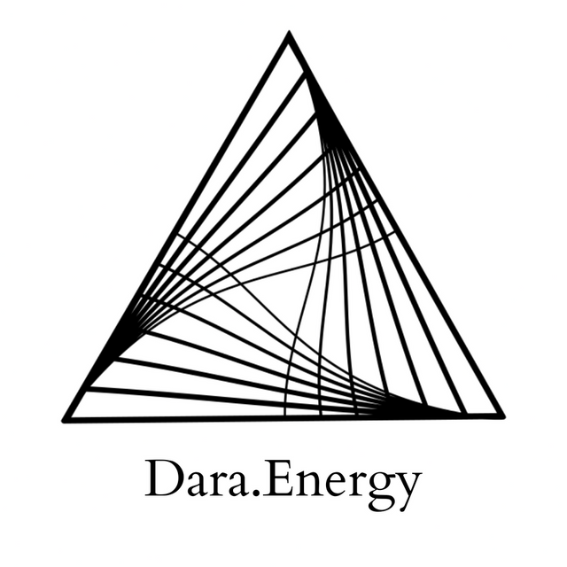

Letting Go: Navigating Endings and Beginnings (death/rebirth cycles)

Hello, I'm Darananda, and this is a healing for endings and beginnings.

The thing that jumps out to me immediately about navigating endings and beginnings is the level of letting go that is required. Both in an ending– whether it's ending a relationship, a job, habit, even a conversation. If you are paying attention, you can start to feel the resolution energies, enter, and then you can watch your experience, your reaction, your response to those energies showing up.

So for example, sometimes when I work with people who are not so comfortable with endings, not so comfortable with letting go. Right at the end of our session, as we're, as we're wrapping up, they will introduce a whole new question, or experience, or material. So right as the ending is arising, they open something new up that they want to talk about, that they want to go into. This is like a common phenomenon for people who do one-on-one healing work.

And similarly, sometimes the same people, but sometimes other people, when we begin a session they want to spend several minutes connecting with me first. Warming up. It's not so easy for them to just jump in. It's like oh, we have to, like see what's here.

So in both endings and beginnings, there's a strong theme energetic of not knowing, of uncertainty, of freefall.

So, just offering that as context, and shifting more into the healing space now.

And what's arising is how to support the recognition of the resolution energies so that the release, the purification, the letting go, can happen and the next phase can be entered into. And this is showing up in the throat and in the inner ear. So, the inner ear talks to me about balance. How to maintain balance in these experiences of stepping towards a groundless ground, stepping into the unknown. How to feel grounded when there is no ground.

Yeah, and it's, it's like this experience like, I'm, I'm feeling like a very subtle like nausea, but also it can show up as dizziness. And of course there's fear which is underneath so many of our experiences. And the fear says “I'm not safe” or “I can't handle this” or “I'm not enough”.

Primarily the tension is like in the back of the throat, which is like this particular juncture where the throat opens up into the head and brain. So just looking deeper into this juncture. Yeah, and it just, it strikes me that the throat and the mouth are, are places where endings and beginnings can happen. Like for example: eating. Eating. It's like you introduce food into the body at the beginning, and then it goes through this whole journey being digested. And equally: it's like once you say something, you can't take it back.

And I'm just sensing now particularly in the left temple, and eye, and forehead, this kind of left area, circle almost, that includes the left side of the forehead, the temple and, the eye, the eye socket. There's like a slight pressure. And there is this sense of grief in the throat. And some balancing happening between the two frontal lobes, the two sides of the front of the brain, the right and the left. It's a little bit like a seesaw. So balancing. Yeah.

And what's occurring to me now, is that there's something here about how because we live in such a linear and irrational society, culture, that these experiences of endings and beginnings, they have a sort of finite, energetic that's projected onto them. It's actually not in the energy signature itself. So what does that mean? So we see, I'm just checking, I'm just looking into the energy signature of an ending, of endings. And it, when I look into it: it flips open. So it's like it's an ending, but then It flips open. And let me just see, if I look into the energy signature of beginnings. It's yeah, it's like it's open, and then it like, moves into a single point.

So what's here, is that… Well, from a nondual perspective, we could say there are two sides of the same coin. That the nature of a beginning is inherently nested inside of an ending. And that in the nature of an ending, there is inherently a beginning.

So it's about two things. One, changing our perception. Yeah, it's less about the concept and it's more about perceiving. And when I say perceiving, I mean, how it feels. Changing our understanding of our experience.
And related to that, I'll say more about that in a second. But related to that, is a reimagining, or even a remembering, that experience is not linear. We actually don't experience our lives– if we really look at it from a different perspective, it's more like a cycle or a spiral.

So there's a download coming in, to support the system in moving towards experience as something which is cyclical, and spiral, and not linear. And this is just anchoring below the, just in between below the heart and above the solar plexus. So in between, in between the third and the fourth chakras. In between the solar plexus and the heart chakra, there's this anchoring here. It's a little bit, like, like a ballast, or a compass even. But finding our balance in more of a cyclical, spiral, spiral-like spiral, spiral, spiraling experience of time and space and of ourselves. So it's like finding our sea legs with cycles.

And this is like reformatting. It's not a word I use very often in this healing context. But there's like a reformatting happening throughout the nervous system and the subtle body from that anchoring up… all the way up, all the way up the physical body. And then also reformatting up the upper chakras. So the reformatting of this way of knowing, experience, as something that is more like a cycle or a spiral.

And then coming back to this piece around perception. And that brings us back into that throat area. So there's this grief here. Grief and confusion, and maybe a sense of failure. Like oh this didn't work, I failed, or I don't want to have to start over, start over, starting over, beginning again feels like failure, shame. So just investigating how to clear, how to clear this. And that drops us into the heart.

There's a particular type of compassion here, in the heart, that says “You didn't know. You didn't know.” And I want to add: we are in a society, a culture, where not knowing is very problematic. Very scary, shameful. This is the old, patriarchal, masculine issue that we all have. This need to know. So there's this compassion in the heart that says: “You didn't know. You didn't know how this would play out. And also it's okay not to know. Enter into the innocence. The innocence of not knowing. This is the medicine. This is the opportunity. That primordial innocence.”

This is the Divine Masculine. We don't see it very often in our society. But it's something we all deserve to access: the divine innocence. And there's just so much light here, so much brilliance, pure white light. And that's just streaming forth from the heart. “It's okay. You didn't know. How wonderful it is to not know. You don't have to know.”

And there's just expansion moving through the upper chakras. Another way to say this is that the vibration is moving to a higher dimension. And I say that because I can hear very clearly in my direct experience, that there's this hum of the universe that has increased in volume as this healing has progressed. And along with that is this silence and it's deeply stable. And there's a very, very strong powerful energy moving through the front of the perception, the third eye, the top of the head. It's like an upgrade for your perceiving and visionary capacity. So you might have some third eye activation from this still going. Right, and it makes sense because the third eye, it sees beyond time and space and in a way. So it can see the whole picture, can see the whole picture. It doesn't get stuck in these details, these particular aspects, or phases of a particular cycle that you might be in. There's just a washing, a nice clearing, washing just moving down through the whole system, very gentle.

And just want to say here, before we close this healing, that fundamentally where we're looking at the cycle of death and rebirth, creation and destruction, like expansion and integration. And in all of these cases, it's not possible to traverse the full cycle without the letting go, without the purification, and without the not knowing.

So may this be supportive to you on your journey. And thank you for receiving this transmission.

© 2022 Soma Developmental LLC

All rights reserved. No part of this publication may be reproduced, distributed, or transmitted in any
form or by any means, including photocopying, recording, or other electronic or mechanical
methods, without the prior written permission of the publisher.

