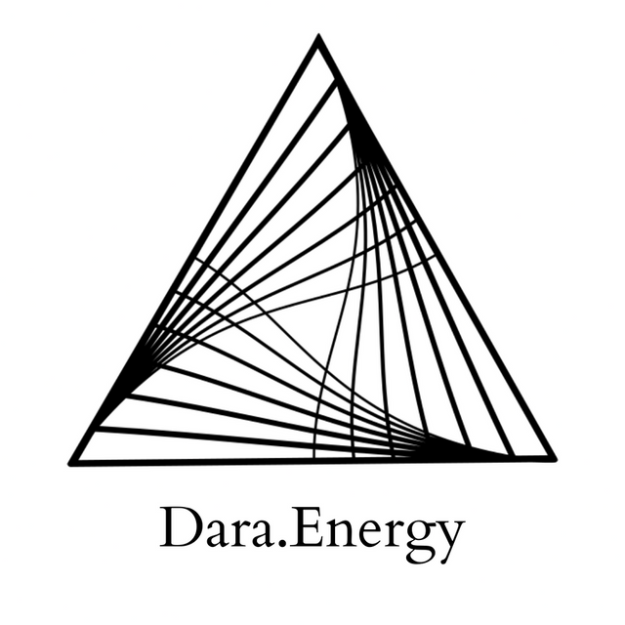

Support for Initiations

Hello, I'm Darananda, and this is a healing for working through initiations. Support in initiations.

And I'm just going to begin by talking about this topic a little bit here to get us centered, and aligned. It seems many people are going through initiations at this time, in what I'm calling “The Great Fragmentation.” And in this Great Fragmentation, it's like there are more boundaries being put into place. And more versions of reality, starting to co-exist and co-evolve. And these boundaries, and different versions of reality, can bump up against each other. Just very like, you know, in your office, or even in your family, for example. So they're very close. And there's something about those who are ascending–we could say, who are becoming more whole, and more liberated, and more open at this time–are going through a process of entering into kind of a whole new, uncharted, dimensional experience. And I imagine, just based on what I know, and understand about the laws of nature, that those are highly different and varied. And there is this kind of common denominator of being initiated into new dimensional experiences that are somehow totally novel, and unique, and new.

And the other thing that I'll just add at this moment is that part of what's happening, in terms of these initiations, is that they're quite accelerated. Everything is kind of turbocharged right now. So it might be that quite literally, everything in your life is changing. Where you live, what you do for a living, your partner, who you relate with, your understanding of what life is, your embodied experience, like it could all be changing all at once. Just as an example. And maybe in the past, it wouldn't all happen at the same time, but because we're in this very unique period: it's all happening. So these initiations are, they're fast and furious. They're confusing, they're powerful. And they're, they're full of change. Even day to day might feel really different.

So just beginning by looking into this, this phenomena, this experience that so many of us are going through at this time. And there's a sensation here of kind, of the stomach kind of flipping over. It's kind of like, whoa, like a little bit of a roller coaster experience. And so there's something about the solar plexus, in terms of honoring thyself. How we honor ourselves. How we work with our personal power. And there's this piece around personal power, and particularly something one of my teachers, Dorothy Rowe, has been speaking on recently. The ability to own, or have autonomy over, how you redefine yourself as being central to healing, central to growth. So this piece about sovereignty and having sovereignty over the experience of the initiation. Even if it's like not in your control, like it's not about being in control, right? It's more about surrender, and navigating, sensemaking, sensing into what's happening. And being able to come back in to yourself through this process. And to have a sense of your own experience of redefining yourself, of yourself being redefined by the initiation. So there is a level of choice in how you participate or engage with what you're experiencing.

So a couple things I'm understanding. One, is just how this, this process that showing up at the individual level, is a mirror. It's like a microcosm, or fractal, of how Source is always evolving itself, and redefining itself. That is just the nature of things. That is how we at the material level of form, that is how we have change and impermanence that is what we know. So there's that mirroring, that fractal, of Source happening at the level of the individual.

Just kind of hang out with that for a moment. And there's just like a nice kind of washing through the system. This level of recognition, Source recognizing itself in the reflection of this experience of initiation. And there's something here that arises around purification. How there can be aspects that are being purified in the initiatory process, even as the initiatory process is also a cycle that leans heavily into the expansion of consciousness, the expansion of Self.

And there was a second piece that I was understanding a moment ago. And I'm just pausing here to stay with this process a little longer. Yeah, and I'm just understanding how, how, initiations are complex. Insofar as, well, there are always cycles happening within cycles. But there's something in particular about the different aspects of, for example, the cycle of evolution. Like I just mentioned, there's, there's expansion happening at the same time that there's purification happening, cycles within cycles. Whereas on a kind of broader scale purification is a part of the overall evolution cycle. That is, that follows expansion. So it's like, it's like multiple, we could say it's multiple timelines, that are happening, occurring, at different levels of the system in the initiatory process.

And then, of course, there's a level of integration that has to be playing out as well. But my sense is that the integration aspect, even though it might be happening at some level, is much harder to kind of see clearly, when you're deep in the integration, or in when you're deep in the initiation. So if the initiation cycle is kind of the larger picture, and then you have kind of the small smaller experience of purification happening, while there's expansion moving through the system as well. And there is inherently integration happening, because that is the aspect of the, the kind of grounding, finding the grounding, or finding your kind of footholds through the process of what you're being initiated into, or I want to say on to.

So I'm just looking into all of these cycles within cycles in this moment. And they're sort of like a cushioning. Like a nice energetic cushioning, coming in to support how all of these cycles are happening simultaneously at different levels in kind of different timelines, but all in the individual initiatory experience. So it's quite a lot. It's a lot. But yeah, this nice cushioning coming in.

Yeah, and there's something like little Alice in Wonderland, like Alice Through the Looking Glass, that's occurring to me here. Where we might make a choice, or a series of choices, that kind of push us over the edge. It's like the fool card in tarot. And it's like when we're making the choices, we don't necessarily recognize that by making and that choice, or those series of choices, that it's going to kind of push us through, we're going to fall through the looking glass and then find ourselves in this like this like, oh, wow, okay, like a little bit of like a freefall experience.

There's that Chögyam Trungpa Rinpoche quote where he says something like, the bad news is that you're falling through the air and there's no parachute. The good news is that there is no ground. Which isn't to say that you will forever be inside of an initiation, or a kind of threshold experience, where you're moving through multiple, complex timelines and cycles at once. You know, things do move in cycles and in phases. So there will be something like grounding. But this maybe deeper recognition comes through about the nature of surrender, and impermanence, and again, kind of flipping through to the other side not of being in control, but in refining the sensing capacity, so that you can kind of dynamically steer through these moments.

And so there’s just a download coming in. Particularly like I'm feeling it in the sinuses. So it's like, happening in the skull. The third eye. The pineal gland. Also coming down into the heart. And this download is, is, for that, is for the refining of the sensing to dynamically steer as you move through these these kind of rapid transitions.

Yeah, it's just like really, it's like, this whole thing of just, like, taking your hands off the steering wheel. And allowing, allowing, allowing, allowing, so much allowing, sensemaking, and then kind of dynamically steering based on what your understanding as you sense into okay, well, what is what is actually happening here? What is being communicated? What do I need to know and understand not through the cognition necessarily, but through the direct experience?

Yeah, there's something like a fortification moving through the like the respiratory system, the lungs, just some clearing through the throat, and the jaw. Yeah, a lot of density clearing, like the quality of holding is clearing from the neck, the throat, and the jaw.

So again, this allowing, this allowing, allowing, allowing.

And there's this piece here around patience. Knowing when to act, knowing when not to act. So patience and kind of right action, or right waiting. And how that is related to your sovereignty. So that your, so that your nervous system is less likely to get hijacked, either by the ego, or by anxiety in the field, or other people around you, or pressure to make a decision, or a choice that isn't actually ripe. So this important role of patience, and waiting, and right action, that comes from the place of sovereignty, of allowing, and this capacity to redefine yourself.

Just checking to see if there's anything else here. Yeah, and again, there's just this like this nice washing, washing the system, washing the system. Like, just of all of the, the dust, and the debris, and the hormones, everything that gets kicked up, and stirred up, and released through times of intensity times of change. You know, how the reptile brain gets agitated. So just a nice washing and clearing through the system.

Yeah, and I'm just feeling a nice expansion and connection with Source. Like for those of you who have that, that kind of hum, the hum of the universe, as my teacher calls it. Who you can, like, hear you kind of can hear, the universe, or you can hear this kind of hum, that's like very clear and kind of Crystalline. In my in my Sensing, my hearing, right now. And so that always brings this quality, of or it's like a signal that yeah, that we've kind of raised the vibration. Like, quite literally like we've raised the field here to a higher vibration.

So may this be supportive to you as you move through whatever initiation or initiatory phase that you are in at this time.

Thank you for being with me.

© 2022 Soma Developmental LLC

All rights reserved. No part of this publication may be reproduced, distributed, or transmitted in any
form or by any means, including photocopying, recording, or other electronic or mechanical
methods, without the prior written permission of the publisher.

