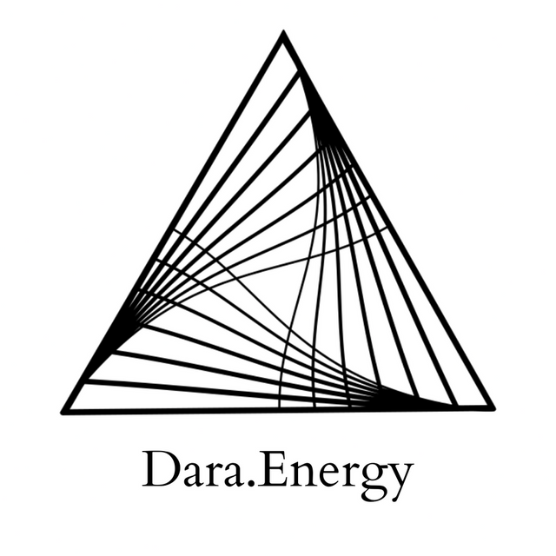

Live Group Healing: 05.28.22

Okay so just beginning by closing the eyes, if that feels available, and just starting to become closer, more intimate with your own experience here. And if you'd like, you can take three deep and clearing breaths: in through the nose, and out through the mouth. You can also place a hand on your body, if that feels supportive.
Just continuing to arrive with yourself.

And just noticing how whatever you're making contact with the floor, or the seat, that ultimately you're held. And just starting to sense into that experience of being held in the physical experience, the physical dimension. So just exploring how the physical feels right now.

And sensing into the mental dimension. Just checking out what is the mind activity like today? What is the quality of the mental experience? So we're just taking a perspective that's open, and non-analyzing, non-judging. Just an open perspective of experience.

And just sensing into the emotional dimension, just seeing if there's anything there? And if there is, you're welcome to offer it to this group, for transmutation. Into this healing space.

And sensing into the spiritual dimension. Whatever that means to you and however that might show up today.

And taking this multidimensional perspective and experience just back to the heart. The heart integrates all.

And just staying open, and receptive. And what is most present for me in this moment is a sense in the crown. Particularly the front, more the front of the crown. And it feels like a kind of cracking open. There's a lot of light there. And it's starting to move down the temples. And there's a response from the heart. There's like a yearning from the heart for this divine light to come into form, come into the heart. And similar to the crown, I'm feeling…it's like a stretching, or a cracking open. And for me it's like, particularly in, like, the bottom of the heart, like right in the center of the chest. This desire to expand in all directions.

And this interplay is interesting. There's a very vertical experience from above. And then this undeniable, like, horizontal emanation from the heart. And I just feel that Divine Light traversing, moving down, like a column of light moving down, into the head, and throat, and chest. Into the heart.

I just feel there's a sense of tenderness there. Just there's also, like a little bit of, like, confusion, desire, wanting things to change and be different. And underneath that, there's that experience of feeling helpless. Maybe hopeless. And there's just a subtle spiraling in the back of the heart. Just some opening in the lower chakras, in the lower body. Some opening and clearing. It's making space for this column of energy to continue to descend down the body.
And just receiving whatever is now happening in your experience– even if it differs from what I'm narrating. It's all perfect.

Just this column of light is moving all the way down. And I'm feeling some clearing at the top of the chest, and also the shoulder. For me, it's in the right shoulder. Some clearing in the higher heart chakra which is also the thymus, and this clearing is moving up the throat, clearing the throat, clearing the brainstem, clearing the autonomic nervous system, clearing any residual of the fight or flight, the freeze or fawn response. It's like a rebalancing of the cortisol, clearing the brain. And that's just continuing to spiral up and clearing the upper chakras– eight through ten, eight through twelve, these are above the head.

There's just like more of a fluid quality arising, more flow, more movement. And just feeling that column of light moving through the legs, and the feet opening. So this grounding quality with the Earth. And I'm just feeling this circuit of energy that's coming down the central channel, from the crown, and then looping out of the heart, and around the front of the body, and coming back down. I'm just gonna stay with this circuit for a few moments. And clearing any resistance to purification, clearing impressions, and memory patterns that have kept you from being able to access your direct experience. Have kept you from being able to access any held emotion in the body. And also there's something very calibrating here that is for those who might be over-feelers. Just knowing what is the right amount to feel.

I'm just going to leave us there.

So, slowly, slowly, slowly, in your own time, no rush to reemerge.

© 2022 Soma Developmental LLC

All rights reserved. No part of this publication may be reproduced, distributed, or transmitted in any
form or by any means, including photocopying, recording, or other electronic or mechanical
methods, without the prior written permission of the publisher.

